# Getting Started with the Fabric User API

The Fabric User API provides developers with the ability to automate tasks in the Fabric environment such as creating and managing Fabric workspaces and workspace items. The developer sample in this repository named **FabricUserApiDemo** is a C# console application which demonstrates creating Fabric workspaces and Fabric workspace items included semantic models, reports, lakehouses and notebooks.

The design of the Fabric User API is based on REST principles, established programming patterns and best practices for moving data across the network as efficiently as possible. The Fabric User API is secured using open security standards including Open ID Connect and OAuth2. The Fabric User API use of REST and open security standards in its design is what makes it accessible to any developer on any development platform.

You can call the Fabric User API under the identity of a user or under the identity of a service principal identity. Note that the initial Public Preview release does not include full support for executing calls as a service principal. Full support will for executing calls as a service principal will come in early 2024. It is recommended that you that you conduct your testing by executing Fabric User API calls as a user through the end of 2023.

The Fabric User API is accessible in the public cloud through a base URL for of **https://api.fabric.microsoft.com/v1**. Before calling and endpoint of the Fabric User API, the caller must first acquire access token from Azure AD. Once the access token has been acquired, the caller must transmit it in all API calls using **Authorization** header.

In early 2024, Microsoft will release the Fabric User API .NET SDK. The biggest benefit of the .NET SDK is that it abstracts away executing HTTP request and converting JSON sent and received in API calls to and from .NET objects. However, the Fabric User API .NET SDK is not available with the initial Public Preview release. Therefore, there is code in the **FabricUserApiDemo** project which executes HTTP request directly using the .NET **HttpClient** class. The project also in includes custom serialization classes which are used together with the .NET **JsonSerializer** class to convert back and forth between JSON and .NET objects.

## Setup

In case you have not heard, Microsoft recently renamed ***Azure Active Directory*** to ***Microsoft Entra ID***. In the past, you would uses the Azure AD portal to create an Azure application which can be used to call Microsoft APIs such as the Microsoft Graph API and the Fabric User API. Now, you will use the **Microsoft Entra admin center** to create a new application for the C# console application named **FabricUserApiDemo**. Start by navigating to **Microsoft Entra admin center** at the following URL.

* [**https://entra.microsoft.com/**](https://entra.microsoft.com/)

On the home page of the **Microsoft Entra admin center**, drop down the **Applications** section in the left navigation and click the **App registrations** link.

](https://github.com/PowerBiDevCamp/TOM_CreateFabricDataset/blob/main/images/media/image42.png)

On the **App registrations** page, click **New registration**.

](https://github.com/PowerBiDevCamp/TOM_CreateFabricDataset/blob/main/images/media/image43.png)

Give the new application a name of **Fabric User API Demo** and leave the Supported account types setting with the default selection of **Accounts in this organizational directory only**.

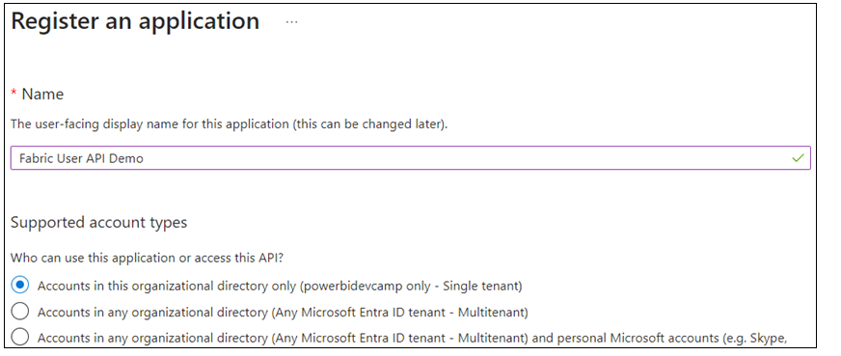

Move down to the **Redirect URI** section. Select **Public client/native** application in the drop down menu and enter a redirect URI of [**http://localhost**](http://localhost/). Make sure to create the URL with **http** and not **https**.

](https://github.com/PowerBiDevCamp/TOM_CreateFabricDataset/blob/main/images/media/image45.png)

Click **Register** to create the new application.

](https://github.com/PowerBiDevCamp/TOM_CreateFabricDataset/blob/main/images/media/image46.png)

Now that you have created the application, you need to record Application ID for use later in the C# console application. Copy the **Application ID** from the application summary page in the Microsoft Entra admin center.

